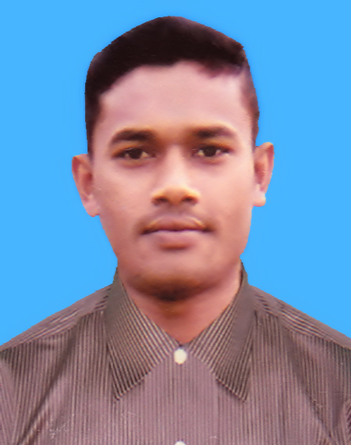
MD. IMRAN HOSEN
Contact Information

G-mail: imranhosen.ih1997@gmail.com
Mobile: 01744-624736

Career Objective

To work in a dynamic, intensive environment, where the creativity and interest can be found to develop the skills as well as the career with a strong emphasis on sustained growth and development.

Academic Qualification

Diploma in Engineering
Institution : Jessore Polytechnic Institute, Jessore.
Technology : Power Technology
Roll No : 823078
Reg. No : 752246
Result : 3.48(Out of 4)
Passing Year : 2018
Board : Bangladesh Technical Education Board, Dhaka.

Secondary School Certificate (S.S.C)
Institution : Bidya Nandakathi Rashbihari Secondary School.
Roll No : 120692
Reg. No : 1113413662
Result : 4.69 (out of 5.00)
Group : Science
Passing Year : 2014
Board : Jessore

Training & Internship/Extra Course

No | Organization | Course Tropics | Duration
1 | HTN Institute Of Science & Technology | Auto Mechanics | 6 Months
2 | HTN Institute Of Science & Technology | Motorcycle Mechanics | 3 Months
3 | Prottasha Computer Institute | Office Application | 6 Months
4 | Ghop Santral Road, Jessore | Industrial Training | 3 Months

Strength
→ Able to work under pressure.
→ Excellent understanding power in any situation.
→ Like to take challenges.
→ Excellent interpersonal communication skills.
→ Willing to learn and work hard.

Language Skill
- Bangla
- English

Personal Profile
 Name : Md. Imran Hosen
 Father’s Name : Md. Nazrul Islam
 Mother’s Name : Morium Begum
 Date of Birth : 25/12/1997
 Nationality : Bangladeshi (By Birth)
 Sex : Male
 Height : 5 Feet 3 Inch
 Weight : 50 Kg.
 Marital Status : Unmarried.
 Religion : Islam
 National ID No : 6901737459
 Blood Gruop : B+

Present Address & Permanent Address
 Village : Mirzapur
 Post Office : Mozidpur
 Police Station : Keshabpur
 District : Jessore
 Post Code : 7450

Declaration
I do herby declare that all information here is true to my knowledge. If required and where applicable, this document can be supported by authentic certificate paper.

Reference
No | Name | Designation | Organization & Location | Mobile No
1 | Anas Ibna Hossain | Executive | Bangladesh Honda Private Ltd | 01729-211058
2 | Md. Rofiqul Islam | Chief Instructor | Jessore Polytechnic Institute | 01714-479322

Experience

- Bangladesh Honda Private Limited. Abdul Monem Economic Zone, Gazaria, Munshiganj , Supervisor, February 1,2018 to April 25,2019.

Date & Signature

........................................
Date : Md. Imran Hosen

